/\*

Ashok

Tables and Matrix lab

6.6.19 \*/

1… Sales by Month Drilldown

Design

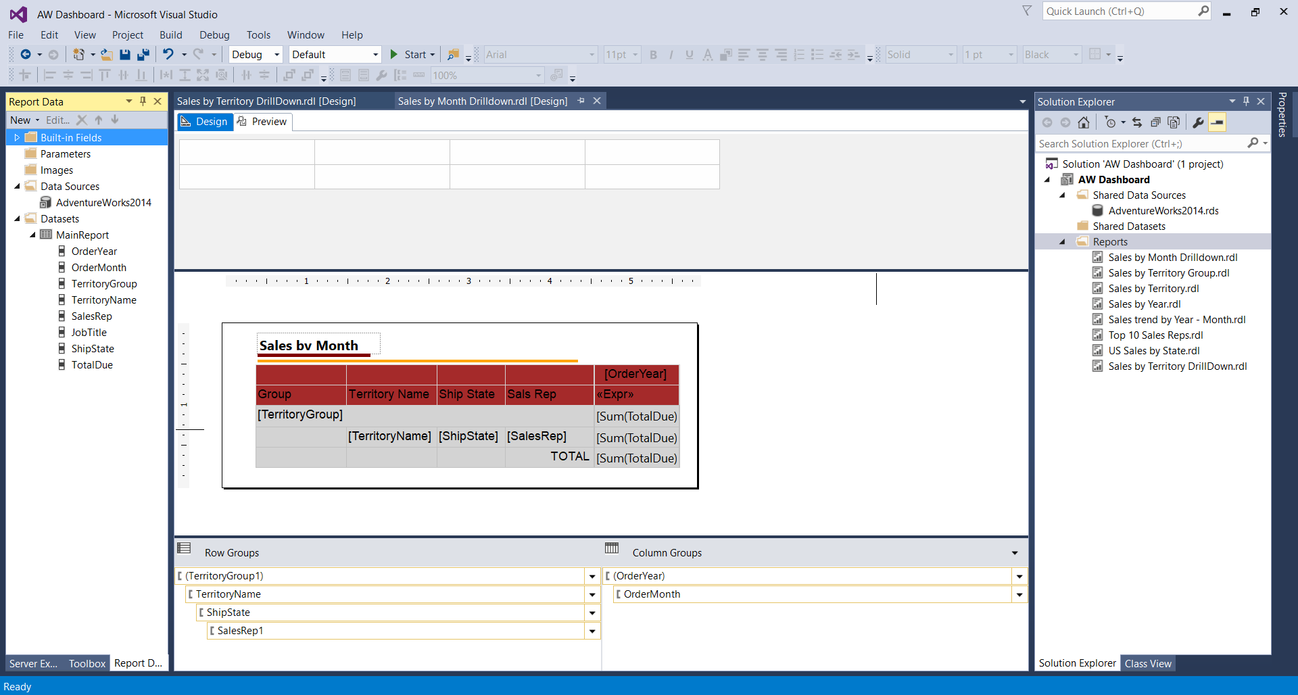

Preview

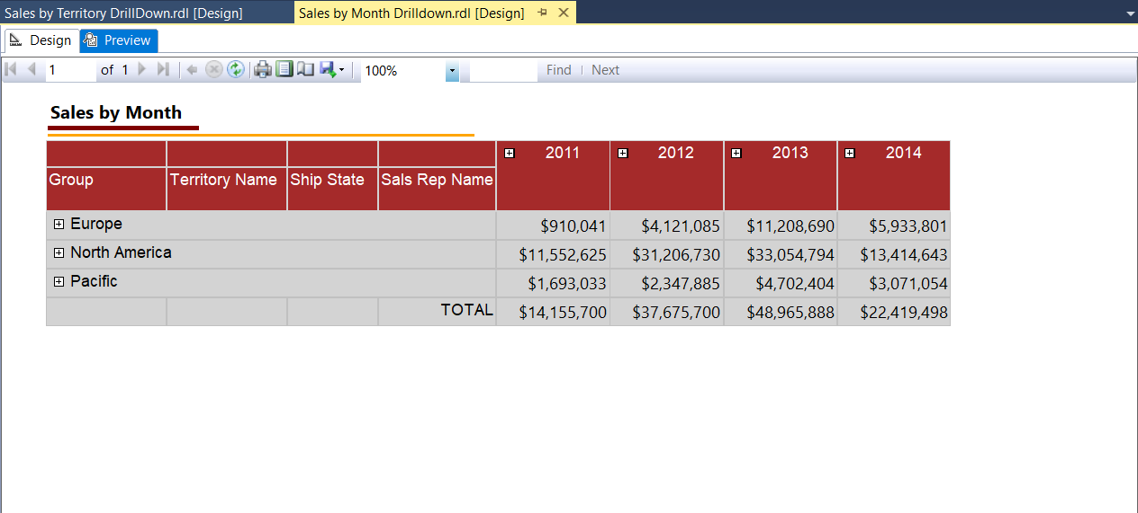

Preview Expanded

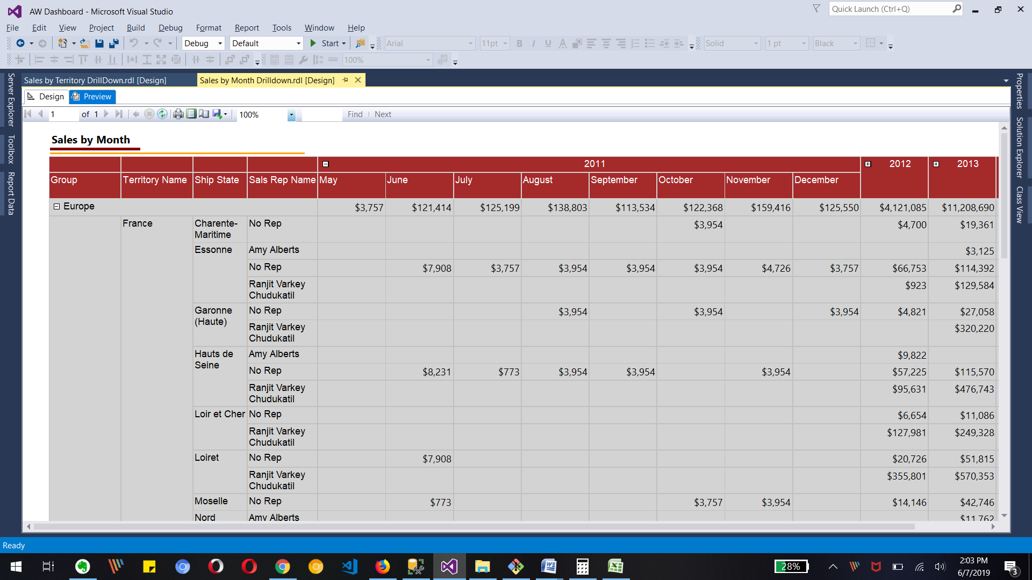

2… Sales by Territory Drill Down